# Creating api using azure functions

## Email Service

1. Login to Azure Portal with contributor and search for ‘Function App’ under specific resource group.

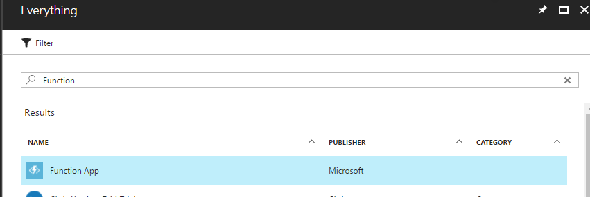

1. Click on ‘Create’ button as in below screen.

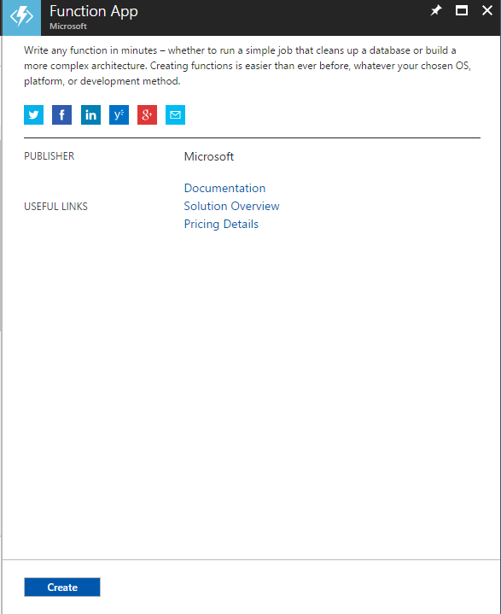

1. Enter Function details and click ‘Create’
   1. App Name
   2. Subscription – default
   3. Resource group – default
   4. Hosting plan – as per requirement
   5. Storage name

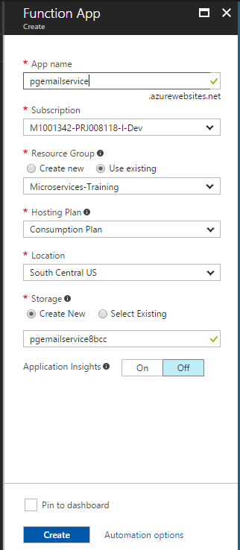

1. Below screen appears post successful creation.

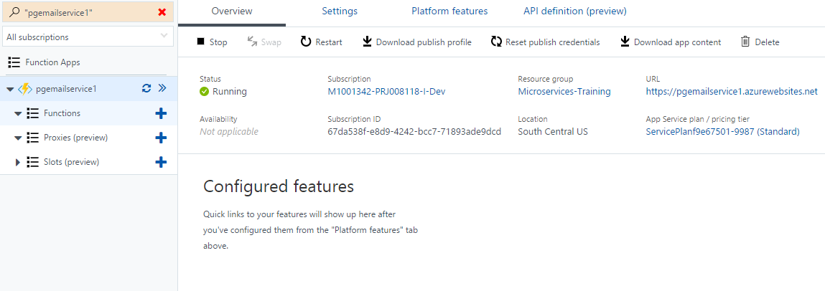

1. Select ‘C#’ as language and HTTPTrigger as function type. Enter below fields:
   1. Name of your function
   2. Authorization Level - Function

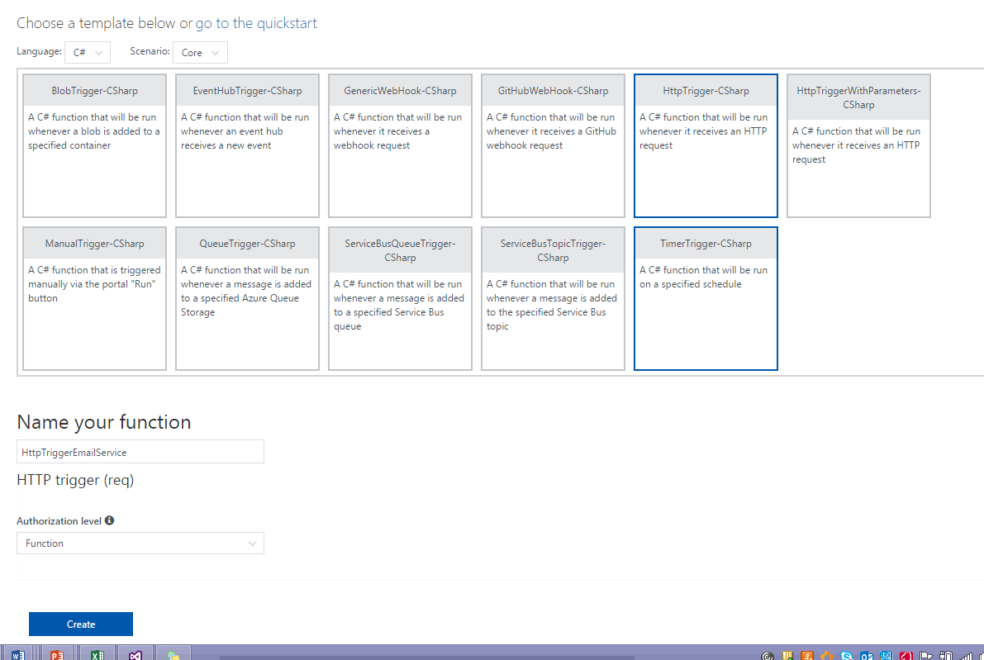

1. Navigate to <Name of your function> -> Integrate.
   1. Select:
      1. Allowed HTTP methods – selected methods
      2. Required parameter name
      3. Route template
      4. Selected HTTP methods – POST (in this case)

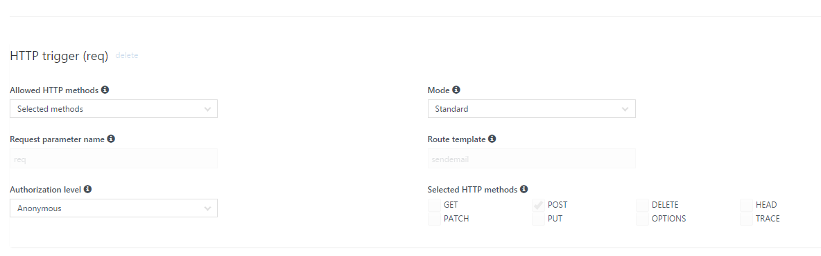

1. Click on function name and edit ‘run.csx’. Enter code to send emails logic. Copy and paste below attached codes from EmailCode.txt:



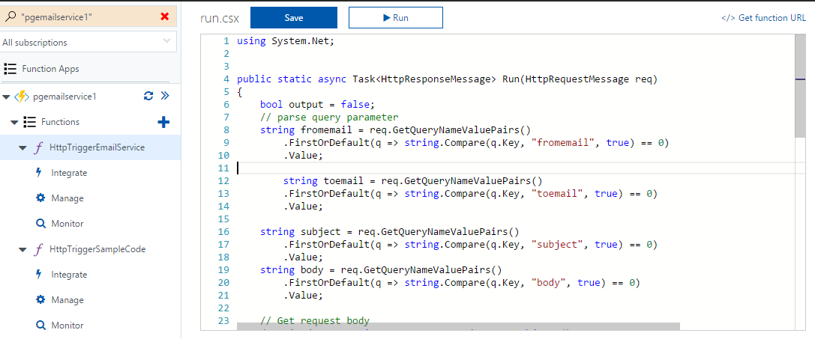

1. Click Save and Run to check the outcome of the function. Output status code 200 means operation is successful.

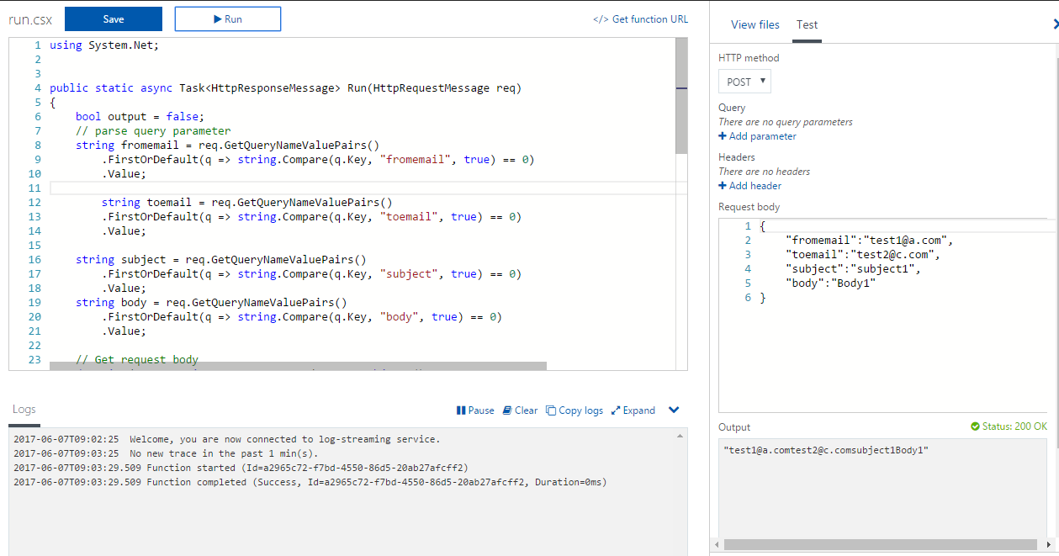

1. Adding Swagger metadata, from Azure Functions landing page, click on ‘API Definition (Preview)’.

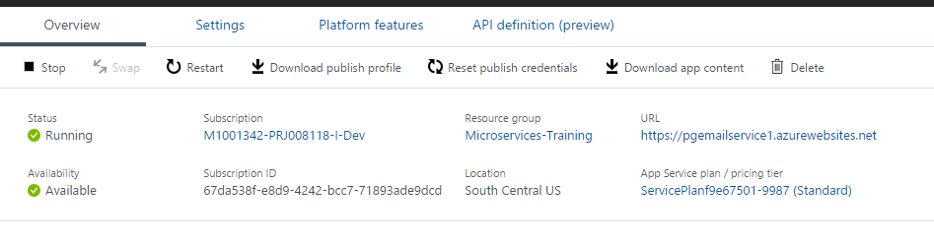

1. Click on ‘Generate API Definition template’. Copy and Paste swagger metadata from attached text file into Swagger editor.



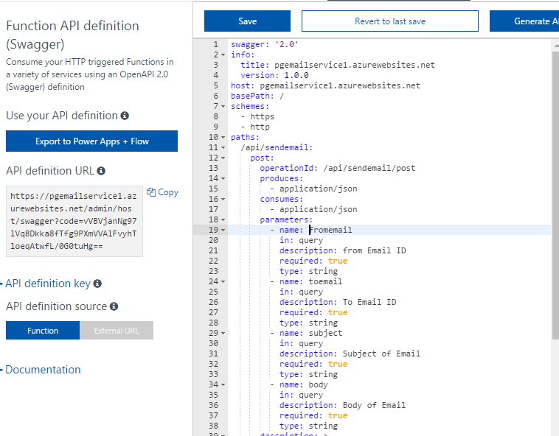

1. Click Save.
2. Try the swagger metadata from panel as:

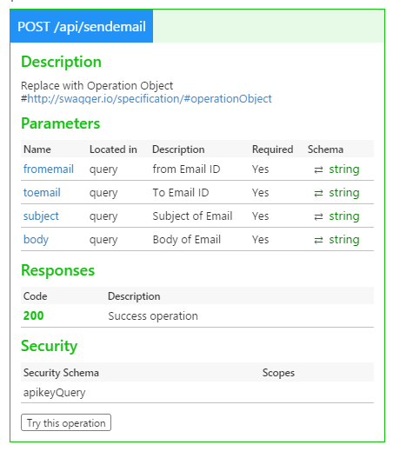

# Configure Continous deployment (if code is already checked in github)

Git URL: <https://github.com/divanshuk/pgemailservice1>

1. Login to Azure Portal and Navigate to Azure function ‘pgemailservice1’.

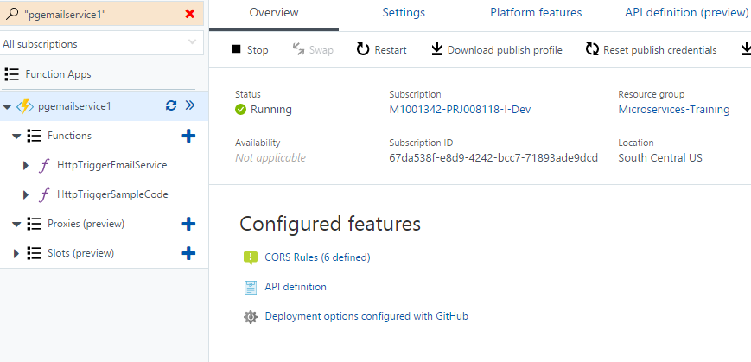

1. Click on ‘Platform features’.

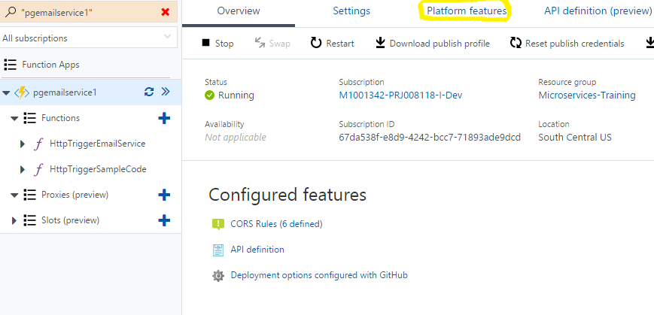

1. Enter deployment credential as and enter the credential needed for deployment.

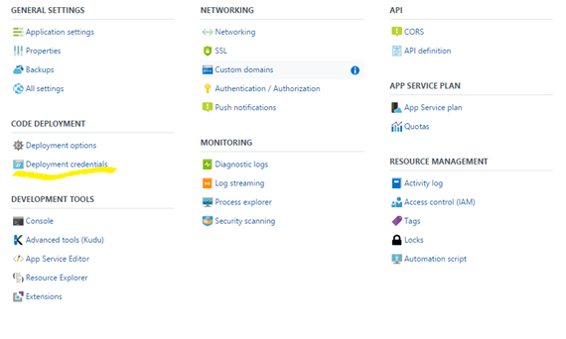

1. Click on Deployment Option as:

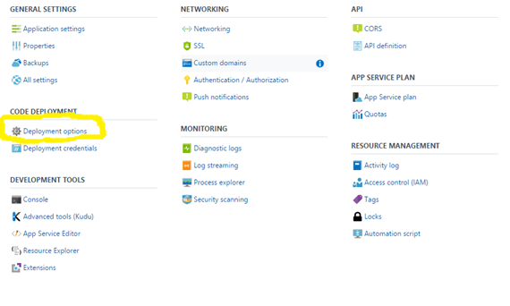

1. Follow the below screens for setting up CD:

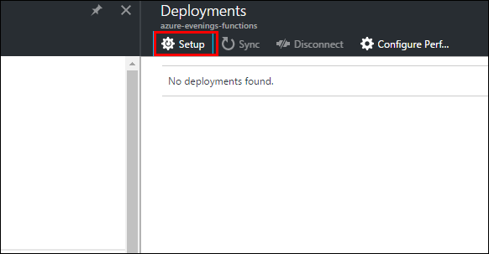

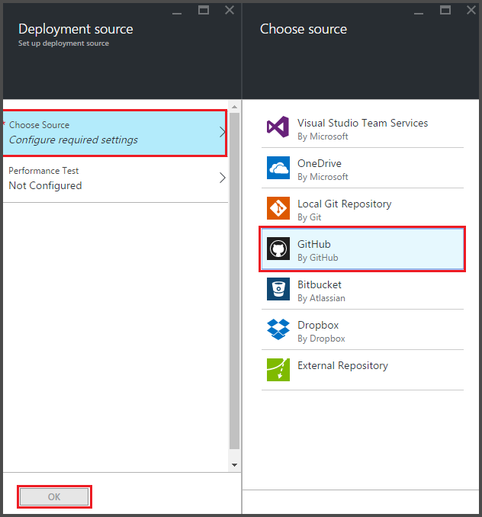

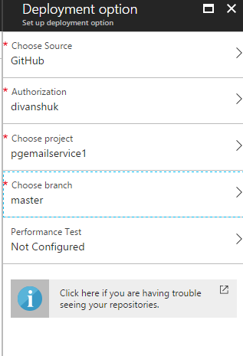

# References

* <https://docs.microsoft.com/en-us/azure/azure-functions/functions-continuous-deployment>